CSS 3

1. Box Shadow

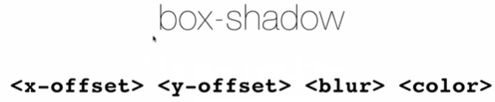

Implementation :

